A.I. Ethics K-12

Incorporation Summary: CU Lab Info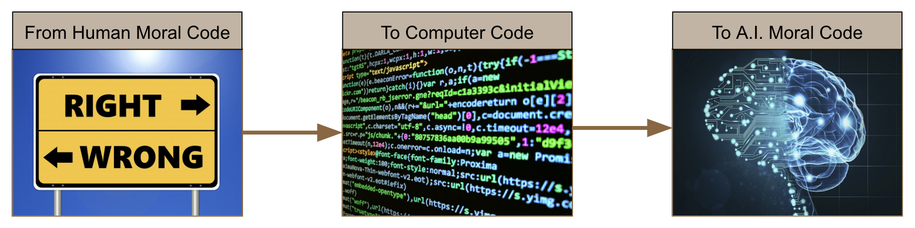

**Team: Tom Yeh, Matthew Turner, Bridget Dalton, Eleanor Haberl, Stacey Forsyth**

**Summary:** Our CU team is working on translating higher education discussions around the ethics of A.I. into deliverable content for students in the K-12 community. Our grants funding currently supports 3 years of work. The first step is to integrate 2-3 hours of ethics content into pre-existing robotics summer camp programs. We will be taking data comparing classes that have been exposed to ethics content versus classes that have not. After this is complete our team will be looking for opportunities to expand our outreach to schools across Colorado and the nation. The material can be completed without prior experience in computer science and is best suited for social studies / science cross-curricular classrooms.

The Course Description below describes the class Turner is teaching right now at Rise Up community school and will be continuing to teach at a pre-collegiate summer camp at CU (or other partaking entities).

**Course Description:** Artificial Intelligence is spreading rapidly throughout civil society, transforming traditional industrial structures that have been in place for decades. We are officially entering what is known as the Fourth Industrial Revolution; education, government, infrastructure, commercial industry, manufacturing, and all other components of society are evolving. This course is intended to help students grasp the notion of technosocial opacity; a societal affliction that arises from rampant technological expansion blurring our ability to predict future outcomes. This blurring effect is a direct result of the Fourth Industrial Revolution. To solve this students will discuss and debate traditional ethical frameworks in comparison to modern ethical frameworks with the intention of clearing our vision and manifesting a global minded, virtue ethics approach to AI. Students will learn the technical basics and know-how of AI and Big Data to prep them for its ethical use in the near future. This technology is a powerful tool, growing exponentially fast, let us work together to ensure it is used equitably, responsibly, and with care.

**Core Purpose:** We will teach students how to teach themselves and teach the class using these Three Pillars of Effective Teaching. Students in the Fourth Industrial Revolution will benefit from learning how to teach in order to put the tools of the future to good use. This is not just curriculum intended to teach the ethics of A.I. It is intended to prepare students for a radically different future.

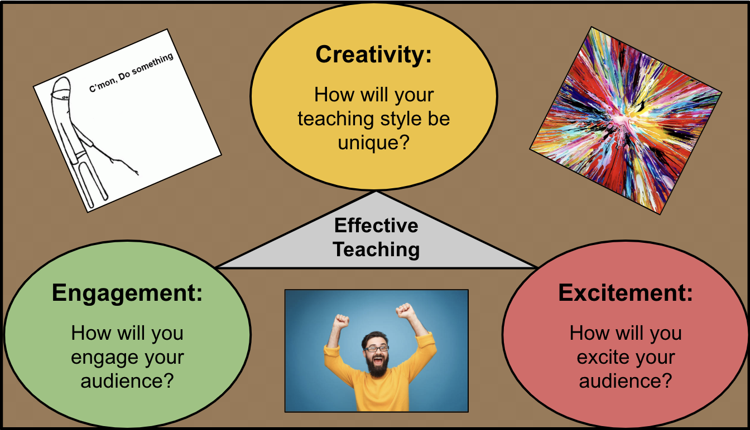

**Bulleted List of Content (In Chronological Order):**

* Collaboration Based on Student Strengths
* Data-Driven Ethical Principles
* Relativism vs. Absolutism vs. Objectivism
* Utilitarianism vs. Consequentialism
* Gray Area Concept Project
* Virtue Ethics
* 4 Technical Basics of AI - Perception, Machine Learning, Heruistics, Representation, Natural Interaction
* Basics of Coding - edTed Coding Game "Think Like a Coder"
* The Fourth Industrial Revolution
* Automation / UBI / Utopia or Dystopia
* AI Morality - Student Driven Research
* 8 Primary Ethical Concerns
* Ethical AI Uses - Student Driven Application (Like a Makerspace)